Daniel Calverley
Web, Pgm, & Db Foundation (2023SP.CTI.110.0001) Unit One Lesson 3Wireframing and Site Map

Content
Home – The homepage will explain that the site was created; to help people interested in Cyber Security learn what resources are available to them for free or very low cost. This could also include news feeds from vetted sources.
Training – This page will contain links to free training that I’ve collected over the past few years. This section might also include links to paid training
Resources – This will focus on cheat sheets created by me and acquired from various sources over my career in cyber security (fair use/copyright laws observed). This media will primarily contain PDFs and images.
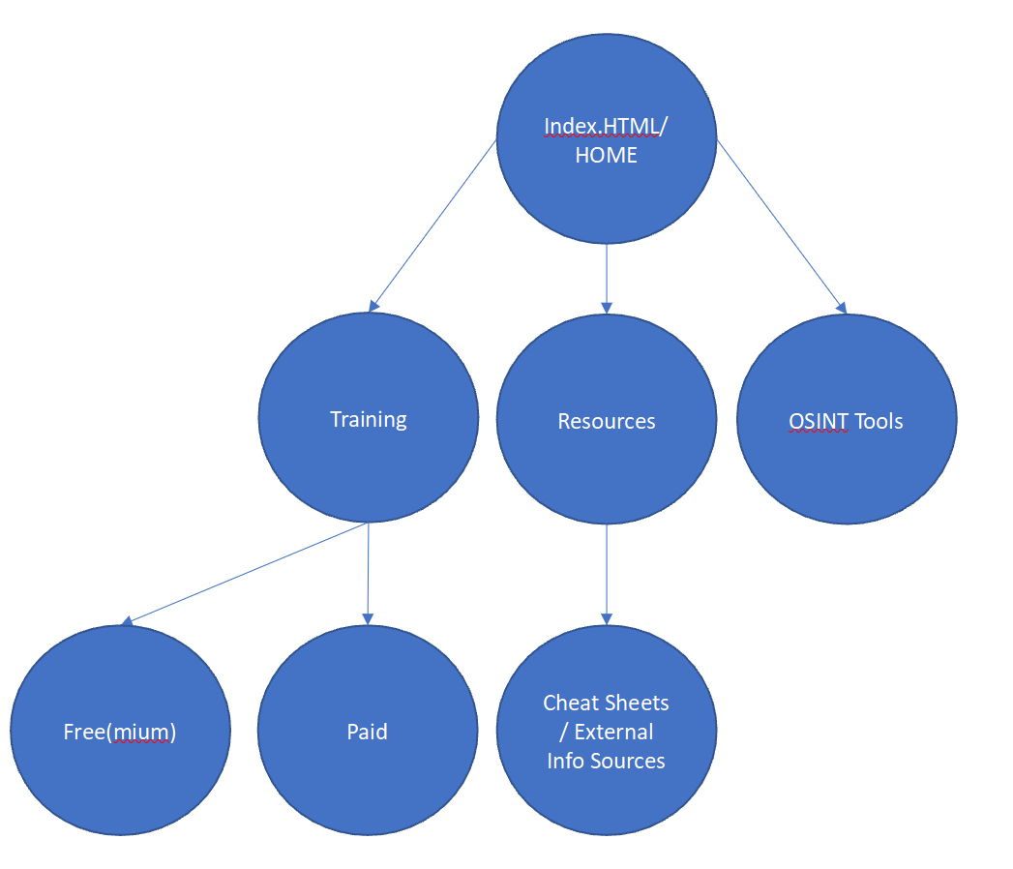
OSINT Tools – Open source or publicly available tools that can be used to educate visitors. This will also include usage guides on tools the average person can use to educate themselves on cyber risks.

